Calculate Energy Bills Affordability

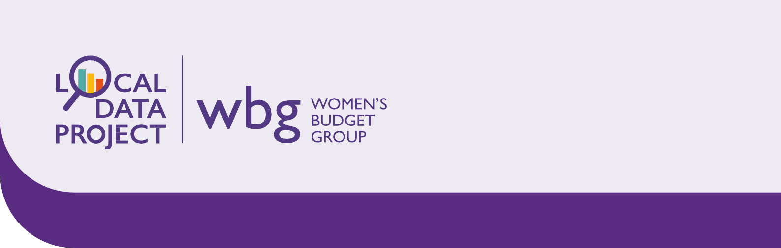

'HOW TO' | September 2022

**Local analysis**

**Why is energy bills affordability important for women?**

Women tend to have lower average earnings than men due to the gender pay gap. This means they are likely to feel the impact of the cost of living crisis — including rising energy bills — more sharply.

Previous analysis by the Women’s Budget Group has demonstrated how women are disproportionately affected by other rising costs, including housing and formal childcare. You can find out more about this by visiting our website: wbg-localdata.org.uk.

**What to expect**

This guide will show you where to find local data on average energy bills and calculate their affordability against women’s earnings in your area. Please note that local energy data is not currently available for Northern Ireland.

First, we will show you where to find data on average energy direct debits for your nearest city/large town. We will then show you where to find data for women’s median monthly earnings in your area. Finally, we will show you how to do a simple calculation around affordability and suggest some ways your findings may support you in your activism.

**Let's work through the different parts together.**

First, let’s find out how much the average energy direct debit is in your area. We can find that information [here](https://www.centreforcities.org/data/cost-of-living-tracker/)1.

Scroll down until you see the following information, then click on the arrow to choose your nearest city/large town

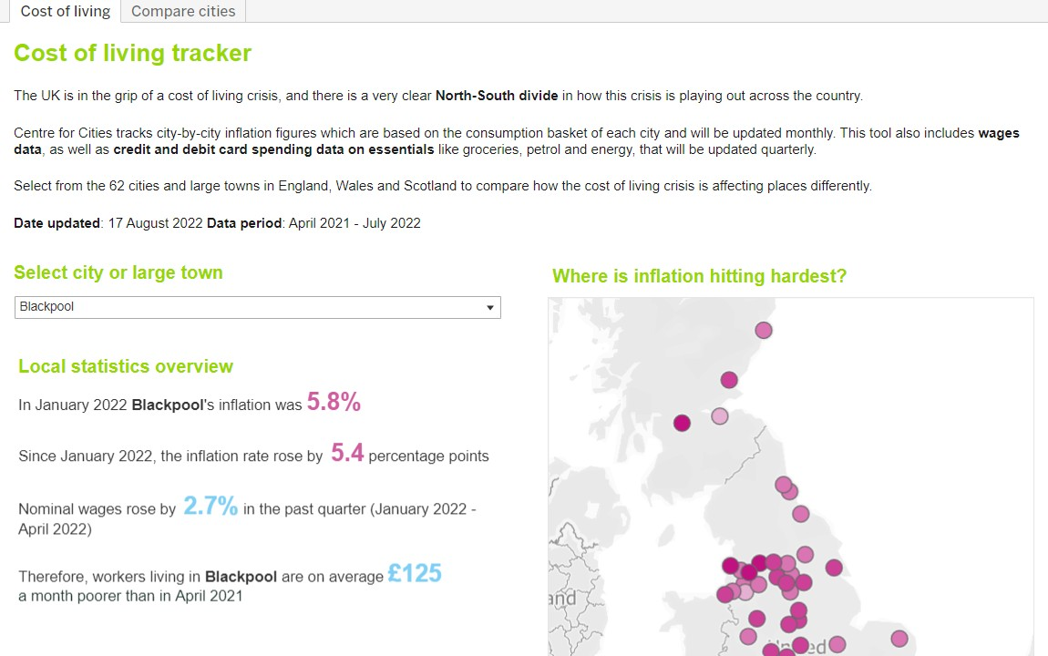

from the drop-down menu.

In this example we will look at the cost of living data for Middlesbrough, but you can choose your own local area.

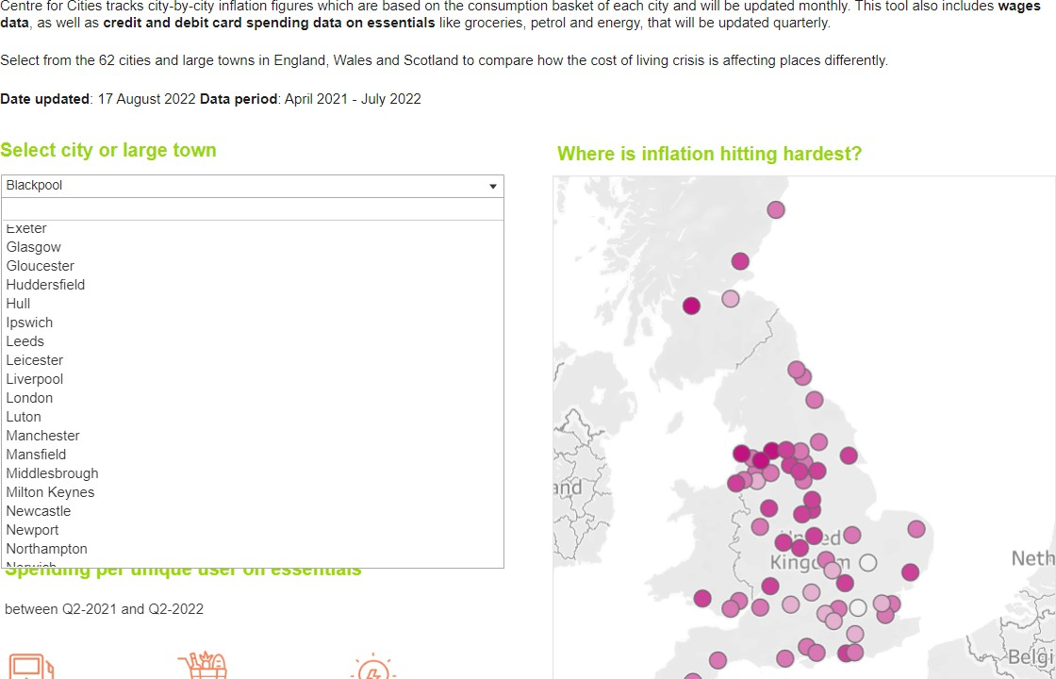

1 https://[www.centreforcities.org/data/cost-of-living-tracker/](http://www.centreforcities.org/data/cost-of-living-tracker/)

This page contains lots of interesting local data regarding the cost of living, so have a good read. You may find some more data that is useful for your local project. For this task, however, we are going to focus on energy bills.

Scroll down the page until you find the graph labelled ‘energy’.

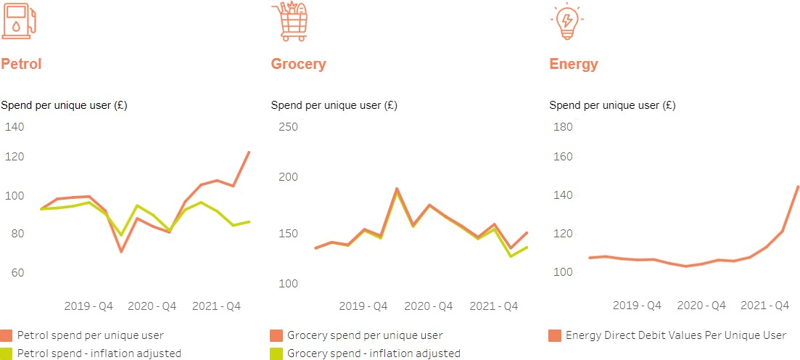

Hover your mouse over the last point on the graph; this will show you the figure for the average cost of a monthly energy direct debit per unique user in 2022 Q2 (or later if you are looking at an updated version of this data). Q2 just means the 2nd quarter of the year 2022 (April-June). Energy bills are set to rise again in the autumn, so make sure you are using the latest figures.

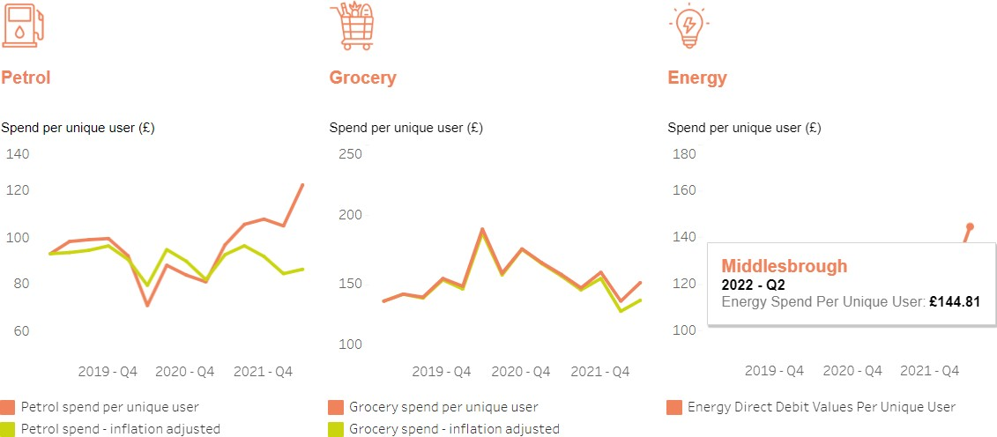

Note: the information box will show when you hover your mouse over the graph. Make sure you are looking at the right year/quarter!

Make a note of the average energy direct debit in your area using the table on the next page. You may find it useful to compare your local area to somewhere else in the country (for example, to show a North/South

divide) so we’ve included a few rows. Feel free to only input data from your area for now, however.

|  |  |
| --- | --- |
|  | **AVERAGE ENERGY DIRECT DEBIT** |
| **CITY/LARGE TOWN** | **£** |
|  |  |
|  |  |
|  |  |

Note:

Direct debits allow customers to spread the cost of energy over the year. Those on prepaid meters (which are not included in this data) pay more per unit and don’t have the option of spreading costs, so will have significantly higher than average energy costs over winter.

Now that we have the information we need on energy bill direct debits, we need to find some local information on women’s earnings. For this we are going to use the Annual Survey of Hours and Earnings (ASHE) dataset on the ONS website. You can find the [correct dataset here](https://www.ons.gov.uk/employmentandlabourmarket/peopleinwork/earningsandworkinghours/datasets/placeofresidencebylocalauthorityashetable8)2.

Make sure you are using the most up-to-date version of the dataset. You can check this by viewing the release and next release dates, and by checking the year before you download the data.

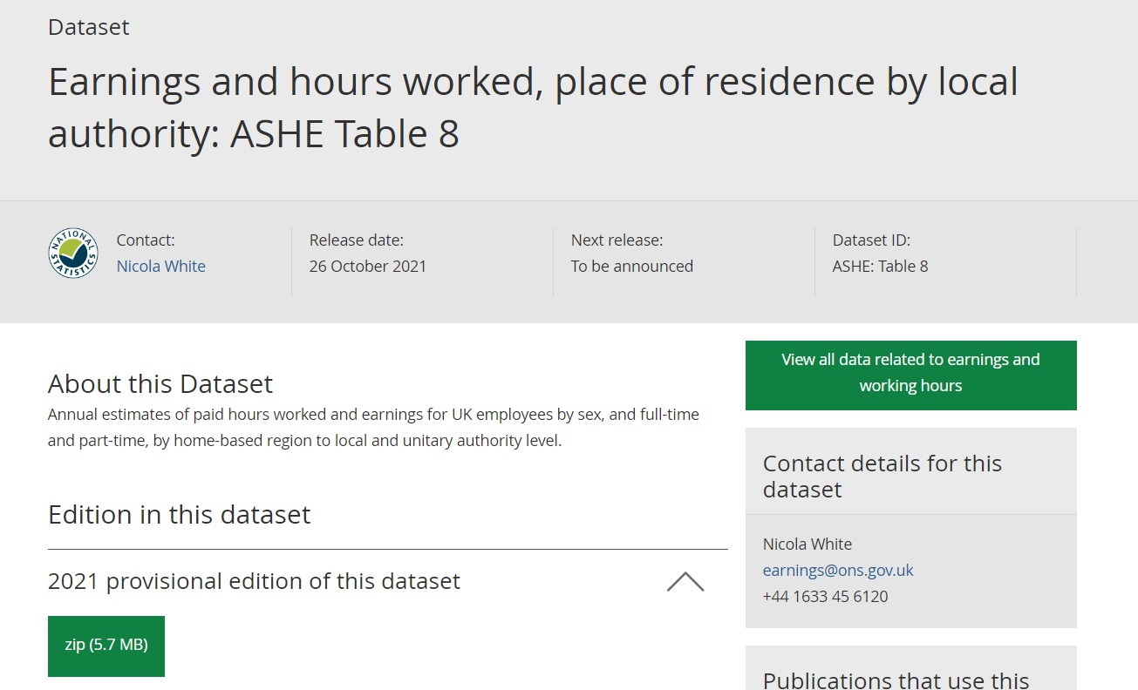

2https://[www.ons.gov.uk/employmentandlabourmarket/peopleinwork/earningsandworkinghours/datasets/placeofresidencebylocalauthorityasheta](http://www.ons.gov.uk/employmentandlabourmarket/peopleinwork/earningsandworkinghours/datasets/placeofresidencebylocalauthorityasheta) ble8

Note:

When looking at data across different sources, it’s important to compare like-for-like whenever possible. For example, you should try to make sure you are looking at data from the same year. In this guide, you will notice that we’re looking at energy direct debits in 2022 but earnings data from 2021. This is because there is a data lag with most datasets, as they are often released yearly (or even less often!). At the time of writing (September 2022), we do not yet have access to this year’s data. The next ASHE release is due in early November 2022, so make sure you use the latest figures if they are available when you come to do this activity. For now, we must use the 2021 data as it doesn’t make sense to look at 2021 energy bills (because they have increased so rapidly in the past year). Wage stagnation and real terms pay cuts due to inflation the 2021 figures still give us a good idea of the cost of energy bills as a percentage of earnings. We have no choice but to work with the data that is currently available, so we do sometimes have to make compromises. Remember that this is okay, as long as you are always transparent about your methods and the limitations of your analysis when reporting your results.

Next, click on the green button that says ‘zip’ to download the data. You will need to unzip the file, but this usually happens automatically when you double click the folder.

You’ll see a lot of files, but don’t panic! There’s only one we need to look at. We’re going to open table 8.7a, because this allows us to see gross annual earnings where people live. Looking at the annual figures is the easiest way of working out monthly pay and gives the most stable picture of earnings over time.

Gross Vs Net Pay

Gross pay is what people earn *before* taxes, benefits, and any other deductions (such as pensions) are taken from their earnings.

Net pay is what people receive *after* taxes and deductions. This is the money that people actually take home.

The ASHE dataset uses gross earnings, so it’s important to remember that the actual amount of money that women have to pay bills and other essentials will be lower than the gross figures shown by this data. This is important when thinking about the affordability of energy bills.

Double click to open table 8.7a.

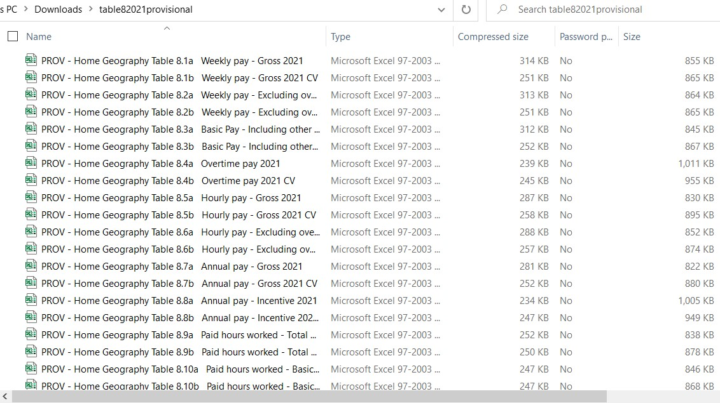

Once you’ve opened the file, you’ll come to the front page, which is a notes page. You may find it useful to read the information, but the main tabs we are going to look at are ‘Female Full-Time’ and ‘Female Part- Time’. If you see a yellow bar at the top of the screen, click ‘Enable Editing’.

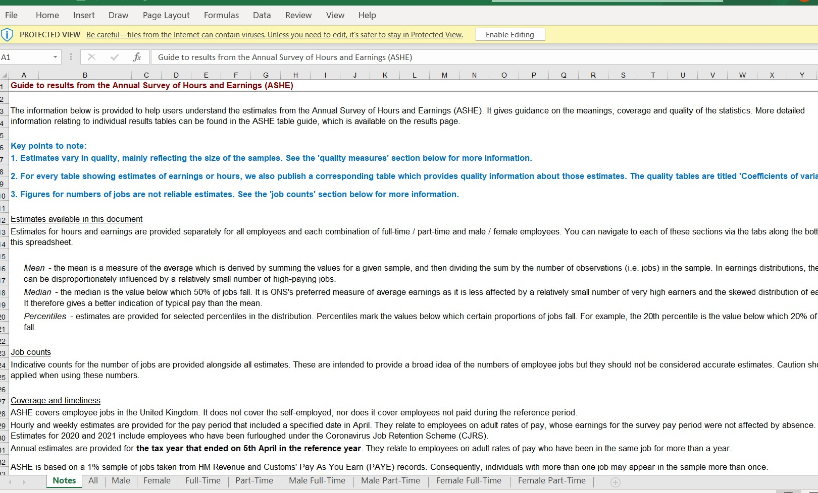

First, click on ‘Female Full-Time’.

As with all ONS data, the regions appear in the same order. Data starts with the big picture for the UK, followed by the English regions, before Wales and then Scotland. First, let’s look at median national earnings, as it will be useful to compare these to earnings in your area.

Mean v Median

It can be difficult to know whether we should use the mean or the median when looking at data. Both refer to the average, but they are calculated in different ways and often give different results. When looking at earnings, it is usually best to look at the median. Here’s an example to explain why:

Let’s say we’re looking at the hourly earnings of 5 women. We want to know what the average earnings are for these women. Their earnings are:

£12, £10, £10, £32, £11

To find the mean, we add up all the numbers before dividing the answer by however many numbers there are (12 + 10 + 10 + 32 + 11 = 75. 75 ÷ 5 = 15). So, the mean earnings = £15 per hour. Can you see a problem here? £15 per hour is in fact more than 4 out of 5 of the women earn. The result is skewed by the single large figure (£32), so in this case it’s not the best way to represent the average.

A better way is to use the median, which simply puts all the numbers in order (10, 10, 11, 12, 32) and takes the middle number as the average. In this example, that makes the median £11 per hour, which is much more representative of the experiences of the women behind the data.

Back to our spreadsheet. Look at the information for Great Britain. Remember that we need to use the median, so the figure for female full-time earnings is **£28,332**.

Next, find the median earnings for your local area. Because the data we used for energy prices was at city/large town level, you should try to use earnings data at the same level. For example, earlier we looked at energy direct debits in Middlesbrough, so we’re going to look at Middlesbrough below.

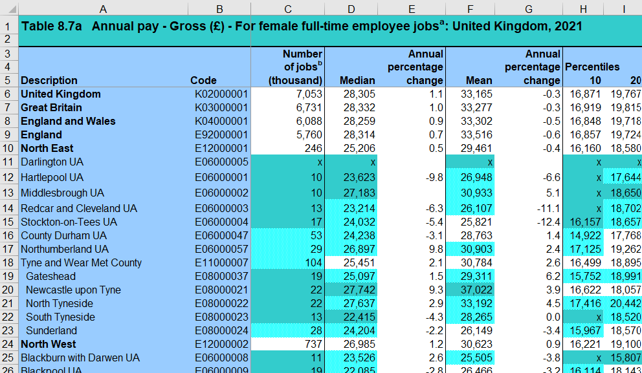

Median female full-time earnings in Middlesbrough are **£27,183**. This is slightly below the median earnings for Great Britain as a whole (£28,332).

To work out median monthly earnings, we can simply divide the annual figure by 12 (because there are 12 months in a year). So, median monthly full-time female earnings in Middlesbrough are £2,265.25 (£27,183 ÷ 12). Let’s round that to the nearest pound: £2,265.

Write down median female full-time earnings in your area:

per year per month

Next, click on the tab marked ‘Female Part-Time’. It’s a good idea to look at part-time earnings in your analysis because a greater proportion of women than men work part-time, especially after they have children (and having children usually means higher energy bills!).

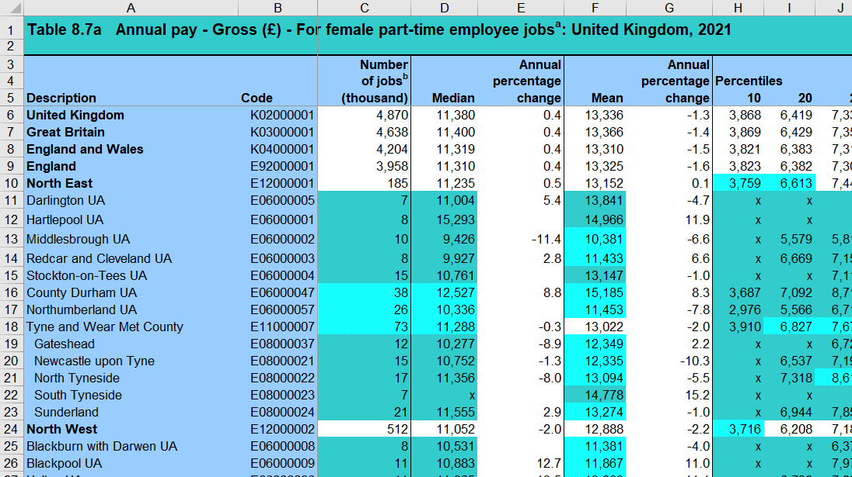

We can see that median female part-time earnings in Great Britain are £11,400.

Median female part-time earnings in Middlesbrough are £9,426. This is significantly lower than the national figure.

Median monthly earnings (£9,426 ÷ 12) in Middlesbrough are £785.50 (let’s round that to £786). Write down median female part-time earnings in your area:

per year per month

We now have all the data we need. We know the cost of energy direct debits in your area, and we know median female full and part-time earnings. Now we need to calculate affordability.

# Affordability

We need to calculate a percentage, so we can use the equation 𝑥 ÷ 𝑦 × 100 = %

Or energy direct debit costs ÷ earnings × 100

The average energy bill direct debit in Middlesbrough was £144.81 (let’s round that up to £145). The energy direct debits data was monthly, so we need to use monthly median earnings in our calculation.

£145 ÷ £2,265 × 100 = 6.4

So, the average energy direct debit in Middlesbrough costs more than **6%** of women’s gross full-time earnings.

We can do the same calculation for part-time monthly earnings in Middlesbrough.

£145 ÷ £786 × 100 = 18.4

So, the average monthly energy direct debit in Middlesbrough costs more than **18%** of women’s gross part- time earnings.

Now do the same calculations for your local area. You may find it useful to fill in the table below to make sure you have all your data in the same place.

Local area:

|  |  |  |
| --- | --- | --- |
| Avg. energy bill  monthly direct debit | Gross median earnings | % of earnings spent on energy direct debit |
| £ | Female gross full-time monthly earnings | |
| £ | % |
| Female gross part-time monthly earnings | |
| £ | % |

# What do my results mean for women in my area?

Once we have our data, we need to use it to tell a story. Here are some things to think about when analysing and distributing your findings about energy direct debit costs in your area.

* You may find it useful to know that an accepted definition of being in fuel poverty is paying 10% (or more) of **net** household income (remember that this is income after taxes/deductions) on energy. The analysis we have done cannot be used as a measure of fuel poverty because the ASHE dataset uses gross earnings (earnings before taxes/deductions) and we are looking at individual rather than household earnings. However, thinking about fuel poverty may help you to put your findings into perspective. For example, if the average energy direct debit in Middlesbrough swallows over 6% of the average woman’s full-time monthly gross earnings, there is a strong chance she will be in fuel poverty once taxes and other deductions are taken out of her pay. [This study from the University of](https://pure.york.ac.uk/portal/en/publications/fuel-poverty-estimates-for-the-uk(adc974d6-15cb-4e9a-9864-623f61aef48d).html)

[York](https://pure.york.ac.uk/portal/en/publications/fuel-poverty-estimates-for-the-uk(adc974d6-15cb-4e9a-9864-623f61aef48d).html)3 has some regional data on fuel poverty which you may find useful if you are writing a report or briefing.

* It is important to bear in mind that energy bills will vary depending on household composition. For example, many women will live in households with an additional income contributing to monthly costs. Single women living alone will likely use less energy than average and thus have lower bills (although the gender pay gap means many of them will pay more for energy bills as a proportion of their income than single men). However, certain groups of women will be disproportionately disadvantaged by the rise in energy costs. For example, lone parents (who are overwhelmingly female) of multiple children may have higher than average energy bills alongside lower-than-average earnings. The York study referred to above predicts that 88% of lone parents of 2+ children would be in fuel poverty by 2023 without further intervention/government support. Further, [research by](https://www.womensaid.org.uk/the-cost-of-living/)

[Women’s Aid](https://www.womensaid.org.uk/the-cost-of-living/)4 has found that the cost of living crisis is preventing women from being able to leave abusive relationships.

* There is a clear north-south divide when it comes to how the cost of living crisis is playing out across Great Britain. For this reason, you may find it useful to compare data from your area across different localities (e.g. if you live in the north, compare your data to somewhere in the south).

# What Next?

Now is the time to combine your findings with your existing expertise. Quantitative data (data that uses numbers) can only tell us so much. The power of this data comes when it is combined with your rich, local knowledge. What are the women you support telling you about their experiences paying their energy direct debits? Can you use this data to support what you already know? It’s also useful to think about the limitations of our analysis. For example, who is excluded from the data? How about those on pre-paid

meters, who pay disproportionately more yet aren’t included in these figures?

Our hope is that you now feel empowered to access data and use it to support your work, whether that is through compiling reports, briefings, or contributing to your campaign work or funding applications.

If you would like to learn more about our Local Data Project and/or the free training we offer, please head to our website: [wbg-localdata.org.uk.](https://www.wbg-localdata.org.uk/)

3 https://pure.york.ac.uk/portal/en/publications/fuel-poverty-estimates-for-the-uk(adc974d6-15cb-4e9a-9864-623f61aef48d).html

4 https://[www.womensaid.org.uk/the-cost-of-living/](http://www.womensaid.org.uk/the-cost-of-living/)